The Start of a Beautiful Friendship: the Human and the Computer
Katie Howley, Class of 2014
(Double Major in Science and Environmental Writing and in Cognitive Science)

Have humans been displaced by computers? Innovations in machine learning, perception, and decision-making have made it possible for computers to supersede some human abilities and replace many jobs that once could only be held by humans. However, two prominent software engineers have created new forms of human-computer collaboration where humans play a critical role in their computational solutions. These solutions were shared at the American Association for the Advancement of Science annual meeting in Chicago in February.
“It is an elegant dance, the person makes computing better and computing makes the human better,” Eric Horvitz of Microsoft Research said in the opening remarks. Distinguished Scientist and Managing Director of the Microsoft Research lab, Horvitz focuses on leveraging the complementary relationship of humans and machines to tackle challenging problems.
Horvitz used The Galaxy Zoo, a citizen science project, to exemplify the powerful relationship between humans and computers to solve an immense problem, mapping all of the galaxies in space. There are far too many galaxies for astronomers to look at, according to The Sloan Digital Sky Survey, which has imaged over a million galaxies. The Galaxy Zoo project allows any site visitor to classify galaxies. This type of citizen science relies on volunteers to contribute. The volunteers evaluate the galaxies using three classifications: shape, roundness, and presence of odd features.
The project “uses machine learning, decision making and planning technologies to ideally glue together the power of a computer galaxy tagger, and human perception,” Horvitz said. Each galaxy is seen by multiple volunteers, allowing scientists to assess how reliable their machine- generated classifications are. With more than 300 million classifications, The Galaxy Zoo has achieved 93% accuracy with 15% of the effort, he said.
This type of accuracy is typical for crowdsourcing. Horvitz used the example of Wikipedia, a collaboratively edited free, non-profit Internet encyclopedia. More than 20 million editors have helped achieve accuracy comparable to Encyclopedia Britannica. Furthermore, most people feel that Wikipedia is more complete than its academic counterparts, Horvitz said. According the New York Times it is ranked fifth globally for most-used websites.
The wisdom of the crowd can also be useful for event-planning. Haoqi Zhang, an assistant professor of Electrical Engineering and Computer Science at Northwestern University, found a way for friends to help people plan their next trip. Zhang developed Mobi, a system that coordinates a crowd to plan custom trip itineraries. “The system can tightly integrate crowd work, community process, and intelligent user interfaces to solve complex problems that neither machine nor interested party can solve alone,” he said.
Zhang described a hypothetical itinerary to illustrate the value of Mobi. “Let’s say you’re going to San Francisco for a conference and while you’re there you want do two cool artsy things, find one place to read, and one amazing coffee place all in two hours before a conference,” he said. Referencing Yelp, Trip Advisor, and other travel sites can provide recommendations but usually yield too many to sort through. Asking people on Twitter and Facebook may be futile unless friends are well-traveled.
Instead, Mobi can take the travel wish list and allow people from all over the Internet to make suggestions. The system automatically generates to-do items to focus the crowd’s attention on what problems or requests still need to be addressed. “Mobi illustrates a novel approach for handling human computation tasks that are difficult to decompose,” Zhang said. People can come and go quickly, numerous small contributions amount to a schedule that fits the traveler’s needs. It takes an average of 23 steps to create a complete itinerary.
Above is an example of what the Mobi platform would look like. Left, are the trip goals and what a completed itinerary might look like. The right photo shows the “to-do list;” this is what volunteer would see when the itinerary is still in progress.
More complex systems can optimize scheduling in the office. For the past decade, Horvitz and his research team at Microsoft have been working on PASS, the Personal Assistant for Scheduling System, or a virtual receptionist. The system can understand speech, detect faces, and interpret body motion. It then uses the data to extrapolated patterns about workplace behavior.
Over the past few years, PASS has monitored Horvitz’s behavior and can predict how long his meetings usually are, knows that when he’s running late he cannot be interrupted, and even senses when he’ll be running late. He showed a video to illustrate what it is like to interact with a savvy computer receptionist. A monitor projects a life-like floating female head. She makes eye contact, can distinguish between people talking to her or each other, and is able to collaborate with someone to schedule meeting time with Horvitz.
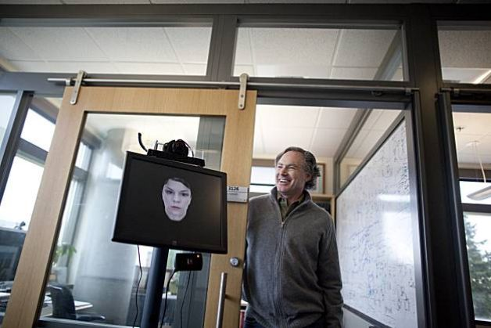

Horvitz poses with PASS, the Personal Assistant for Scheduling System. His virtual assistant has learned Horvitz’s
behavior to make better schedules. Source: Sfgate.com

“Computers are learning our language, instead of forcing us to learn theirs,” Horvitz said. Microsoft Research hopes to develop more tools like PASS that provide natural user interfaces. This is a type of interface that make sense of the activity in the world through senses such as touch, motion, images and sounds instead of a keystroke.
Humans have been able to create computers that can achieve complicated tasks, like facial recognition or IBM’s Watson supercomputer that can beat Jeopardy! champions. However, as the tasks become more complex there is an increasing need for human influence. Most recently, the explosion of data through the web and sensors on devices has produced more data than any human could possibly look at. Humans and computers will work together to optimize the strengths and minimize weaknesses between both parties to decipher the data. In the future look for human and computers to work together to hire new employees, drive cars, and decide court cases. With this new relationship, the possibilities are endless.

